ESP-PROG ESP32
1-VDD 3V3 ou 5V (depende do strap)
2-TMS GPIO-14
3-GND GND
4-TCK GPIO-13
5-GND
6-TDO GPIO-15
7-GND
8-TDI GPIO-12
9-GND
10-NC

1-EN
2-VDD
3-TXD GPIO-1
4-GND
5-RXD GPIO-3
6-IO0
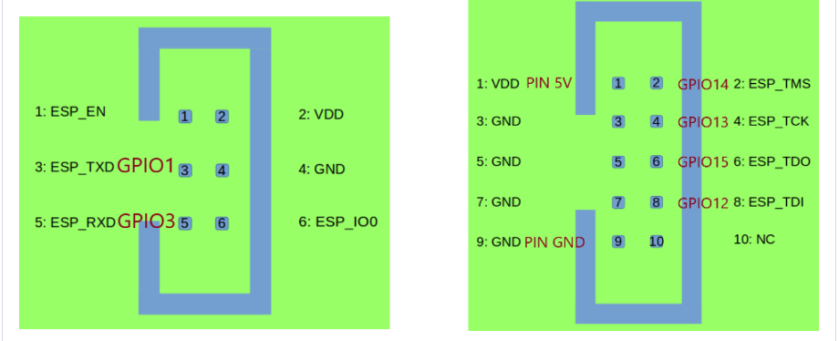

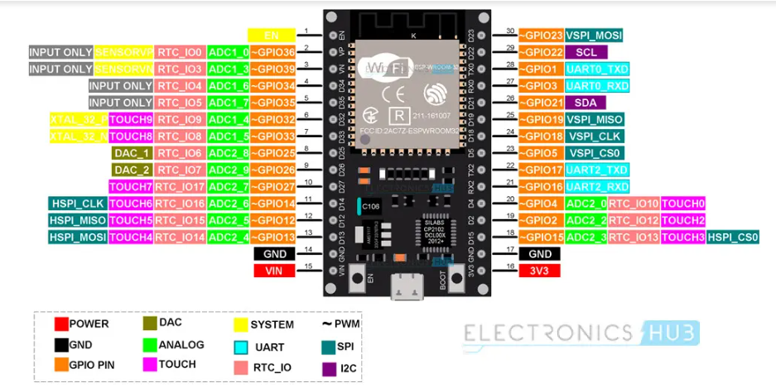

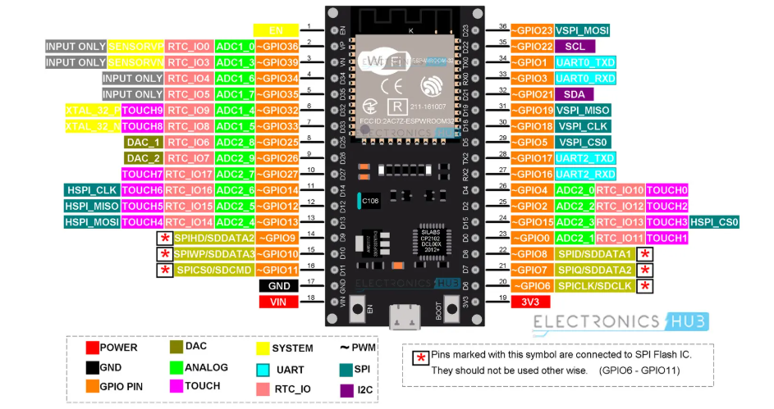

Important ESP32 Peripherals
Now that we have seen a little bit about ESP32 Pinout. Let us now focus on some of the important peripherals of ESP32 and their associated pins. ESP32 Microcontroller has:
- 34 Programmable GPIOs
- 18 12-bit ADC Channels
- 2 8-bit DAC Channels
- 16 PWM Channels
- 3 UART Interfaces
- 3 SPI Interfaces
- 2 I2C Interfaces
- 2 I2S Interfaces
- 10 Capacitive Touch Sensing GPIOs
- 16 RTC GPIOs

ESP32 GPIO Pinout
The most commonly used peripheral is the GPIO. ESP32 has 34 GPIO pins with each pin carrying out more than one function (only one will be active). You can configure a pin as either a GPIO or an ADC or an UART in the program.
ADC and DAC pins are predefined and you have to use the manufacturer specified pins. But other functions like PWM, SPI, UART, I2C etc. can be assigned to any GPIO pin through program.

RTC GPIO
ESP32 has 16 RTC GPIOs, which are part of the RTC Low-Power subsystem. These pins can be used to wake ESP32 from deep sleep as external wake-up source.

ADC
ESP32 has two 12-bit SAR Analog to Digital Converter Modules with 8-channels and 10-channels each. So, ADC1 and ADC2 blocks combined together have 18 channels of 12-bit ADC.
With 12-bit resolution, the output Digital values will be in the range of 0 – 4093.

DAC
ESP32 Microcontroller has two independent 8-bit Digital to Analog Converter channels to convert digital values to analog voltage signals. The DAC has internal resistor network and uses power supply as input reference voltage.
The following two GPIO Pins are associated with DAC functionalities.
- DAC1 — GPIO25
- DAC2 — GPIO26

Capacitive Touch GPIOs
The ESP32 SoC has 10 capacitive-sensing GPIOs, which can detect variations in capacitance on a pin due to touching or approaching the GPIO Pin with a finger or stylus. These Touch GPIOs can be used in implementing capacitive touch pads, without any additional hardware.

SPI
The ESP32 Wi-Fi chip features three SPI blocks (SPI, HSPI and VSPI) in both master and slave modes. SPI is used to interface with Flash Memory. So, you have two SPI interfaces.

I2C
There are two I2C interfaces in ESP32 with complete flexibility on assigning pins i.e., SCL and SDA pins for both I2C interfaces can be assigned in the program by the user.
If you are using Arduino IDE, then the default I2C pins are:
- SDA – GPIO21
- SCL – GPIO22

PWM
The PWM Controller in ESP32 have 16 independent PWM waveform channels with configurable frequency and duty cycle. The PWM waveform can be used to drive motors and LEDs. You can configure the PWM signal frequency, channel, GPIO pin and also the duty cycle.

What ESP32 GPIO Pins To Use?
Let us now take a look at a table which specifies the GPIO pins and their input / output capabilities.
GPIO Pin | Pin on ESP32 | Information
0 | – | Pulled HIGH. Connected to BOOT Button
1 | TX0 | Do not use while TXing
2 | YES | Pulled LOW
3 | RX0 | Do not use while RXing
4 | D4 | Pulled LOW
5 | D5 | Pulled HIGH
6 | – | Connected to SPI Flash IC
7 | – | Connected to SPI Flash IC
8 | – | Connected to SPI Flash IC
9 | – | Connected to SPI Flash IC
10 | – | Connected to SPI Flash IC
11 | – | Connected to SPI Flash IC
12 | D12 | Pulled LOW. Boot fails if pulled HIGH as it sets voltage of internal voltage regulator.
13 | D13
14 | D14
15 | D15 | Pulled HIGH
16 | RX2 | UART2 RX
17 | TX2 | UART2 TX
18 | D18
19 | D19
21 | D21 | I2C SDA
22 | D22 | I2C SCL
23 | D23
25 | D25
26 | D26
27 | D27
32 | D32
33 | D33
34 | D34 | Digital Input Only. No Digital Output.
35 | D35 | Digital Input Only. No Digital Output.
36 | YES | Digital Input Only. No Digital Output.
39 | YES | Digital Input Only. No Digital Output.

GPIOs Connected to SPI Flash IC
If you take a look at the schematic of ESP-WROOM-32 Module, then you will see that GPIO6 to GPIO11 are connected to SPI Flash Memory IC. Even if these GPIO pins are accessible (which are not in 30-pin ESP32 Board), do not use them for any other purpose.

Input only GPIO
There are 4 GPIO pins which are capable of acting as Digital Input only pins. They are GPIO34, GPIO35, GPIO36 and GPIO39.

Interrupts
All GPIO pins are capable of interrupts.

Boot Strapping Pins
ESP32 SoC has 5 boot strapping pins. They are:
- GPIO0 (HIGH during BOOT)
- GPIO2 (LOW during BOOT)
- GPIO5 (HIGH during BOOT)
- GPIO12 (LOW during BOOT)
- GPIO15 (HIGH during BOOT)
These pins are used to put the microcontroller in to flashing mode or bootloader mode.
------------------------------------------
Gravação pela UART:
cd /home/rudolfwaller/Projetos/ESP-32/teste2
BOOT / EN / ~EN / ~BOOT / idf.py flash
Gravação pelo JTAG:
BOOT / EN / ~EN / ~BOOT
cd ~/esp/openocd-esp32/tcl
openocd -f interface/ftdi/esp32_devkitj_v1.cfg -f board/esp-wroom-32.cfg -c "program_esp /home/rudolfwaller/Projetos/ESP-32/teste2/build/teste2.bin 0x10000 verify no_clock_boost; reset; exit"
EN / ~EN => reset
Após a gravação o /dev/ttyUSB0 some

openocd -f interface/ftdi/esp32_devkitj_v1.cfg -f board/esp-wroom-32.cfg
--------------------------------------------
Verificar se existe versão mais nova do openocd (

**************************************************************
Documentação do JTAG: https://docs.espressif.com/projects/esp-idf/en/stable/esp32/api-guides/jtag-debugging/index.html#jtag-debugging-run-openocd
Instalação do esp-idf: https://docs.espressif.com/projects/esp-idf/en/stable/esp32/get-started/index.html
Instalação do esp-idf para Linux: https://github.com/espressif/vscode-esp-idf-extension/blob/master/README.md
**************************************************************
